Date access: 2020-03-10

<http://wjw.beijing.gov.cn/wjwh/ztzl/xxgzbd/gzbdyqtb/202002/t20200202_1622716.html>

From 24:00 on January 31 to 12:00 on February 1, 12 new pneumonia cases of new coronavirus infection were reported in this city

Date: 2020-02-01 Source: Beijing Municipal Commission of Health

        At 24:00 on January 31 to 12:00 on February 1, 12 new pneumonia cases of new coronavirus infection were reported in this city, of which 10 had a history of contact with Hubei and other provinces, 4 were close contacts of confirmed cases, Examples include contacts with both Hubei and other provinces and close contacts with confirmed cases. All have been sent to designated medical institutions for treatment.

As of 12:00 on February 1, a total of 168 confirmed cases were found in the city, 3 in Dongcheng District, 17 in Xicheng District, 28 in Chaoyang District, 39 in Haidian District, 16 in Fengtai District, 3 in Shijingshan District, and 1 in Mentougou District. There were 2 cases in Fangshan District, 13 cases in Tongzhou District, 2 cases in Shunyi District, 12 cases in Changping District, 20 cases in Daxing District, 1 case in Huairou District, and 11 cases came from overseas. No cases have been reported in Pinggu District, Miyun District and Yanqing District.

**1月31日24时至2月1日12时，本市新增 12例新型冠状病毒感染的肺炎病例**

日期：2020-02-01 来源：北京市卫生健康委‍

        1月31日24时至2月1日12时，本市新增12例新型冠状病毒感染的肺炎病例，其中10例有湖北及其他省份接触史，4例为确诊病例的密切接触者，2例既有湖北及其他省份接触史又是确诊病例的密切接触者。均已送至定点医疗机构进行救治。

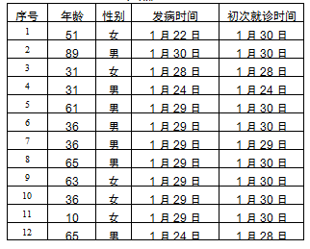

        截至2月1日12时，本市累计确诊病例168例，东城区3例、西城区17例、朝阳区28例、海淀区39例、丰台区16例、石景山区3例、门头沟区1例、房山区2例、通州区13例、顺义区2例、昌平区12例、大兴区20例、怀柔区1例，外地来京人员11例。平谷区、密云区、延庆区尚未有病例。